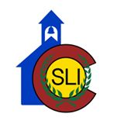COSLI BUDGET – SUMMER, 2020 - 2024

Housing/Dining (Campus Village) ($117,500)
Additional Meals Away from Dining Room 10,000
Transportation 20,000
Resident Counselors 6,000
Credit Class 6,300
Mountain/Outdoor Weekend 12,025
Student Board Retreat 7,000
Salaries and Stipends
Year Round Support/Office 15,000
Executive Director MOU 30,000
Associate Director MOU 20,000

Activity Fund 5,000

Workshop Activity Supplies/Honorariums 5,000

Student Camp Insurance 5,000

Total $258,825

